Cytosponge™ test patient information leaflet

You have been given this information sheet as you have been selected and agreed to have the Cytosponge™ test. The test can help decide which patients need endoscopy.
What is the purpose of the test?
Many people experience heartburn and acid reflux. These can usually be treated with medication and lifestyle changes, for example avoiding eating heavy meals late at night. However, some people who have regular heartburn develop a condition called Barrett’s oesophagus. This is when cells in the food pipe (oesophagus) change shape. About 3-6 people in every 100 with regular heartburn develop Barrett’s oesophagus. People with Barrett’s have a slightly higher chance of developing oesophageal cancer and we know that earlier detection improves outcomes.
It is entirely your decision whether to have the Cytosponge™ test or to go straight to endoscopy.
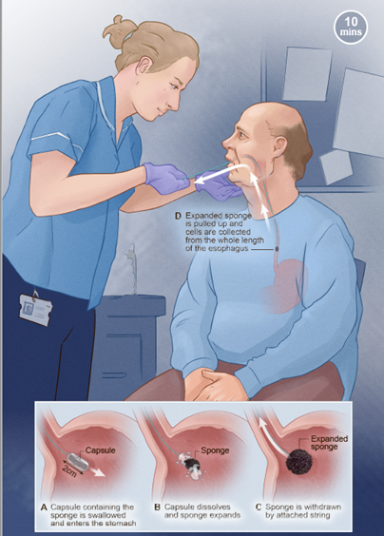
What is involved
An appointment will be arranged for you as an outpatient. The test takes about ten minutes and you will receive the results within 5-8 weeks.
The test will take sample cells and occasionally may need to be repeated.
If your test result suggests you need further investigations, eg an endoscopy, this will be arranged for you.
If you take any medication that acts to thin your blood such as anti-clotting agents (i.e. heparin, warfarin), you may be asked to temporarily stop taking it before the procedure, your doctor will advise you.
You will be asked not to eat or drink for 4 hours before the test (please continue to take any daily medication with a small amount of water).

What will happen at my appointment?
When you attend your appointment, a nurse will go through the test with you and answer any questions you may have. The nurse will then ask you to sign a consent form agreeing to the test
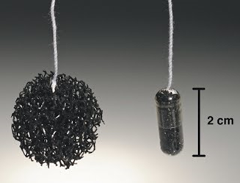
The picture shows the Cytosponge™ which is similar in size to a vitamin pill and contains a small sponge inside a vegetarian capsule attached to a piece of string.
You will be given a glass of water and asked to swallow the pill. The capsule is left in your stomach for up to 7 minutes until it dissolves releasing the sponge.
The nurse will remove the sponge by pulling gently on the string. As it is pulled out, the sponge collects a sample of the cells lining your food pipe (oesophagus).
At the appointment we will also ask you to fill in a questionnaire about your general health, lifestyle, and heartburn/acid reflux and symptoms, we will also ask about your experience of the CytospongeTM test – you can complete this whilst you are waiting for the pill to dissolve.
We will ask for your consent to contact you about taking part in an optional interview/focus group to talk about your experience with us and others and we may also ask whether you would be happy to be observed during the procedure. If you agree to take part in an interview, focus group or observation, your direct quotes may be included in reports or publications but this will be done anonymously, so you can not be identified. Your treatment will not be affected if you prefer not to help with this.
Laboratory testing
The sample that you provide will be looked at in a Laboratory. It will also be tested by clinical or research teams to look for markers of Barrett’s cells and any sign of inflammation or cancerous changes. The results of the CytospongeTM test will be sent to your health care professionals within 2-6 weeks of your procedure and any necessary treatment will be discussed with you.
What are the possible benefits?
It is not possible to offer an endoscopy to everyone with oesophageal (reflux or heartburn) symptoms and currently endoscopy services may have longer waiting times. By having the test, we hope to diagnose any abnormality in the oesophagus easily and to start any treatment as soon as possible. If you are diagnosed with Barrett’s oesophagus or dysplasia (cell changes that may be a pre cancerous), we will be able to offer treatment at an early stage.

What are the possible side-effects or disadvantages of taking part?
- Over 4000 people have had the CytospongeTM test so far with no serious side-effects.
- Swallowing the capsule is not painful and most people do not have any problem swallowing it.
- It is quite common to experience a mild sore throat for 24 hours and in some people this may last for a few days. Paracetamol and throat lozenges will usually help.
- There is a very small risk (less than 1 in 2,000) that the sponge becomes detached from the string or the nurse is unable to remove it. If this happens, you will be assessed and you may need to attend your local hospital for an endoscopy where the sponge will be easily removed.
- There is a very small risk that you will have some bleeding. If this happens, you will be assessed by the Doctor and clinical nurse. This is unlikely to need any intervention but if required an endoscopy at the local hospital could be performed to find and stop the bleeding. This has so far never been needed
- Following the CytospongeTM test, you should be able to carry on with your day as normal.
- If you are referred for an endoscopy this is done in line with the standard NHS referral procedures.

